Alfalah Scholarship Scheme

Admin Block POHSS Mandeer Dinga Road Kharian, Gujrat

WEB: www.alfalahss.org E-MAIL: info@alfalahss.org

Contac# 0092-53-7701299

C:\Documents and Settings\Administrator\Desktop\New.eps

Student Profile



Registration No:

7083/21/01

Sponsored Date:

Jan 2022

Sponsored By:

-

Samia Yousaf

Muhammad Yousaf

Vill: Sohal Khurd, p/O: Jalal Pur Jattan, Tehsil & District: Gujrat

University of Gujrat

BS (Hon) / Feb 2019 to Jan 2023

Student’s Data

Name:

Father’s Name:

Address:

Institute:

Class/Duration

Academic Record

|  |  |  |  |
| --- | --- | --- | --- |
| **Certificates** | Year | Marks/GPA | Percentage |
| **Matriculation** | 2017 | 1100/934 | 85% |
| **Intermediate** | 2018 | 1100/834 | 76% |
| **BS (Hon) 1st Sem.** | 2019 | 3.20/4 | 80% |
| **2nd Semester** | 2020 | 3.26/4 | 82% |
| **3rd Semester** | 2021 | 3.24/4 | 81% |
| **4th Semester** | 2021 | 3.39/4 | 85% |
| **5th Semester** | 2022 | In Process | |

Family Background

Student`s family is consisting of five members. Her father is jobless due to accident while mother is a house wife. She has two brothers who are studying at school and college level.

Financial BBBaStatus

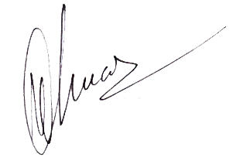There is no proper source of income. Friends and relatives support the family financially to meet their house hold expenses. Family lives in in two room’s personal house. Financial condition of family is miserable. The student is therefore strongly recommended for grant of scholarship.

.

**Program Manager**

Dated: 25th Dec, 2021 Alfalah Scholarship Scheme-Pakistan