Alfalah Scholarship Scheme

The Punjab School, Lajna Chowk Township, Lahore (Pakistan)

WEB: www.alfalahss.org E-MAIL: info.education@alkhidmat.org

Contac# 0092-42-35957260

C:\Documents and Settings\Administrator\Desktop\New.eps

Student Profile

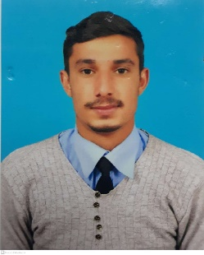

Registration No:

5522/21/11

Sponsored Date:

Jan 2022

Sponsored By:

Naqash Manshad

Muhamad Manshad Khan

Village Kathian, Tehsil Harighal, Bagh AJK

Govt. Post Graduate College Bagh, AJK

BCom (Hons)

Student’s Data

Name:

Father’s Name:

Address:

Institute:

Class/Duration

May 2019 to April 2023

Academic Record

|  |  |  |  |
| --- | --- | --- | --- |
| **Certificates** | Year | Marks/GPA | Percentage |
| **Matriculation** | 2017 | 1100/811 | 74.01% |
| **Intermediate** | 2019 | 1100/704 | 64.02% |
| **BCom (Hons)**  **(1st Sem – 3rd Sem)** | 2020 - 2021 | 2.95 / 4.00 | 69.25% |
| **BCom (Hons)**  **(4th Sem)** | 2021 | In Process | |

\

Family Background

Her family consists of four members. Her father died while her mother is housewife. She has two sisters. All are studying in college and university level.

Financial Status

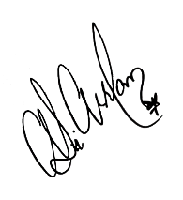Monthly income of family is about 22,000/. Family living in rented house Family financial condition is not stable due to which they are facing financial difficulties. Therefore, the student is recommended for grant of scholarship.

**Manager**

Dated: 13th Dec, 2021 Alfalah Scholarship Scheme-Pakistan