Alfalah Scholarship Scheme

The Punjab School, Lajna Chowk Township, Lahore (Pakistan)

WEB: www.alfalahss.org E-MAIL: info.education@alkhidmat.org

Contac# 0092-42-35957260

C:\Documents and Settings\Administrator\Desktop\New.eps

Student Profile

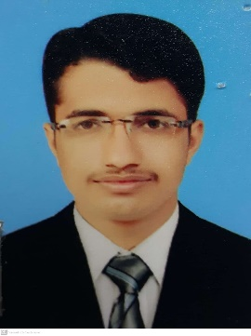

Registration No:

5530/21/11

Sponsored Date:

Jan 2022

Sponsored By:

Muhammad Anees

Muhammad Hanif

PO Sakar, Tehsil Taunsa Shareef, DG Khan

Sheikh Zaid Medical College, Bahawalpur

MBBS

Student’s Data

Name:

Father’s Name:

Address:

Institute:

Class/Duration

Nov 2018 to Oct 2023

Academic Record

|  |  |  |  |
| --- | --- | --- | --- |
| **Certificates** | Year | Marks/GPA | Percentage |
| **Matriculation** | 2015 | 1100/1059 | 96.22% |
| **Intermediate** | 2017 | 1100/1014 | .92.18% |
| **MBBS (1st Prof)** | 2020 | 600/426 | 71% |
| **MBBS (2nd Prof)** | 2021 | In Process | |

\

Family Background

His family consists of six members. His father is a farmer while his mother is housewife. He has three sisters and one brother. They are all studying in school and college level.

Financial Status

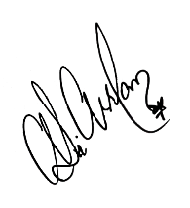Monthly income of family is about 22,000/. Family living in own house Family financial condition is not stable due to which they are facing financial difficulties. Therefore, the student is recommended for grant of scholarship.

**Manager**

Dated: 13th Dec, 2021 Alfalah Scholarship Scheme-Pakistan