Alfalah Scholarship Scheme

The Punjab School, Lajna Chowk Township, Lahore (Pakistan)

WEB: www.alfalahss.org E-MAIL: info.education@alkhidmat.org

Contac# 0092-42-35957260

C:\Documents and Settings\Administrator\Desktop\New.eps

Student Profile

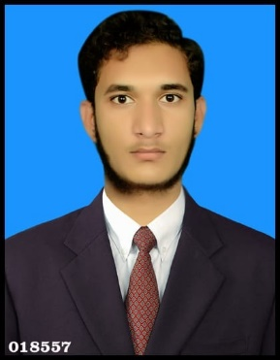

Registration No:

5534/21/11

Sponsored Date:

Jan 2022

Sponsored by:

Rana Zulqarnain

Muhammad Ismail

H. # 86, Jinnah a bad, Bahawalpur

Islamia University, Bahawalpur

BS (Hons) Chemistry (Oct 2019 – June 2023)

Student’s Data

Name:

Father’s Name:

Address:

Institute:

Class/Duration

Academic Record

|  |  |  |  |
| --- | --- | --- | --- |
| **Certificates** | Year | Marks/GPA | Percentage |
| **Matriculation** | 2016 | 1100/1046 | 95.05% |
| **Intermediate** | 2018 | 1100/996 | 91.01 % |
| **BS (Hons) (1st & 2nd Sem)** | 2019 - 2021 | 3.91 / 4.00 | 91.25% |
| **BS (Hons) (3rd Sem)** | 2021 | In Process | |

Family Background

His family consists of three members. His father is a primary teacher and his mother is house wife. He has a sister. which studying in school level.

Financial Status

Monthly income of family is about 35,000/. Family lives in their own house. Family financial condition is not very good due to which they are facing financial difficulties. Therefore, the student is recommended for grant of scholarship.

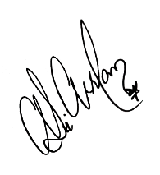

**Manager**

Dated: 28th Dec 2021 Alfalah Scholarship Scheme-Pakistan