Alfalah Scholarship Scheme

Admin Block POHSS Mandeer Dinga Road Kharian, Gujrat

WEB: www.alfalahss.org E-MAIL: info@alfalahss.org

Contac# 0092-53-7701299

C:\Documents and Settings\Administrator\Desktop\New.eps

Student Profile

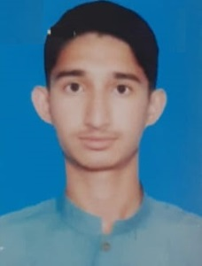

Registration No:

7109/21/01

Sponsored Date:

Jan 2022

Sponsored By:

-

Makhduma Bibi

Mukhtar Hussain Shah

Basti Gull Bninda Syed Haider Shah P/O: Shahani District: Bhakkar

University of Sargodha

BS (Hon) / Oct 2019 to Jun 2023

Student’s Data

Name:

Father’s Name:

Address:

Institute:

Class/Duration

Academic Record

|  |  |  |  |
| --- | --- | --- | --- |
| **Certificates** | Year | Marks/GPA | Percentage |
| **Matriculation** | 2017 | 1100/1031 | 94% |
| **Intermediate** | 2018 | 1100/908 | 83% |
| **BS (Hon) 1st Sem.** | 2019 | 3.68/4 | 92% |
| **2nd Semester** | 2020 | 3.49/4 | 87.25% |
| **3rd Semester** | 2021 | 3.5/4 | 87.5% |
| **4th Semester** | 2021 | 3.52/4 | 88. % |
| **5th Semester** | 2022 | In Process | |

Family Background

Student`s family is consisting of three members. Her parents had died. She has a brother and a sister and they are studying at school & university level.

Financial Status

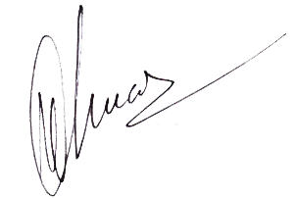There is no proper source of income. All the three orphan siblings live with their paternal cousin who has his own family. It is too difficult for him to meet the education and house hold expenses of both families. Due to pathetic financial position of the family and being an orphan, Makhduma Bibi is strongly recommended for grant of scholarship.

**Program Manager**

Dated: 25th Dec, 2021 Alfalah Scholarship Scheme-Pakistan